20MCA136 – NETWORKING & SYSTEM ADMINISTRATION LAB Dept. of Computer Applications

# NETWORKING & SYSTEM ADMINISTRATION LAB

**Name: MELBIN M P**

**Roll No: 19**

**Batch: S2 RMCA B Date: 05-05-2022**

**Experiment No: 9**

# Aim

Write a shell script to find sum of two numbers.

# Procedure

#!/bin/bash

echo "Enter the number1 :" read num1

echo "Enter the number2 :" read num2 sum=$(($num1+$num2)) echo "The sum is:"$sum

# Output

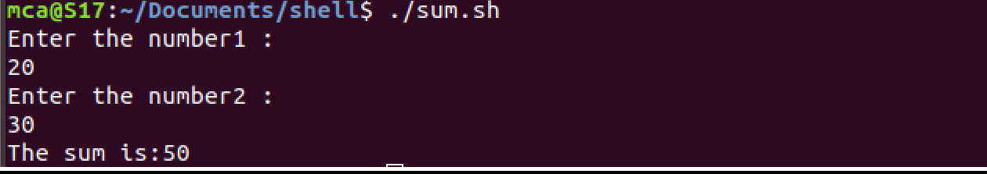

Amal Jyothi College of Engineering, Kanjirappally